**MASTER OF TECHNOLOGY**

**(INTELLIGENT REASONING SYSTEMS)  
  
PROJECT REPORT**

**(COGNITIVE SYSTEMS)**

**National University of Singapore (Institute of Systems Science)  
HEX CHATBOT**

**TEAM MEMBERS OF HEX**

YE CHANGHE  
ZHANG HAIHAN

PAMELA LIN YAN LING

CH'NG WEI LUEN

LIM LI WEI

PREM s/o PIRAPALA CHANDRAN

# Contents

EXECUTIVE SUMMARY 3

1. INTRODUCTION 4

2. PROPOSED SYSTEM 6

2.1. PROJECT OBJECTIVE 7

2.2. WHAT IS DIALOGFLOW ? 7

2.3. SYSTEM ARCHITECTURE 8

3. METHODOLOGY 10

4.1. PROPOSED IMPROVEMENTS 13

### 

### EXECUTIVE SUMMARY

Artificial intelligent chatbots are becoming a more prevalent form of service technology in a variety of scenarios in industries ranging from banking, customer services, logistics and education. Traditional computer interfaces require structured and predictable input in order to function properly, making their use unnatural and non-user friendly. If users are not able to easily understand their structured input, they encounter difficulty in figuring out how to make a query using such a system. An ideal interface should be able to infer what users want, based on the natural language used by the user(s), be it in the format of textual input or speech.This project proposes and implements an artificial intelligent chatbot system for the National University of Singapore (Institute of Systems Science) website (<https://www.iss.nus.edu.sg/>) that allows users to enter textual-based queries that the system will respond with relevant information. The purpose ofthe chatbot system is to allow users to search for the more common information normally termed as  frequently asked questions (FAQs) in a more efficient and responsive way that accommodates for differences in syntax of questioning grammar but is still able to return a relevant response based on keywords in the query via Natural Language Processing (NLP). The effectiveness of such a system is reviewed based on efficiency of performance and effectiveness of functionality. Based on the review, we suggest some proposals to improve the robustness of the system.

### INTRODUCTION

One of the more impactful and common applications of the chatbot technology is the information retrieval from websites. Normally in searching for specific information on a website, the user has to scan and peruse through the information to make sense of it. This is a time-consuming process that can cause cognitive overload on the person, which if needs to be a repetitive process where if many different queries needs clarification, will lead to a detrimental human performance over time. One way to improve the efficiency of information retraction from websites is to leverage on the affordances of chatbot technology. Such chatbot systems respond to queries made by voice and text purely by a process of information extraction based on the user’s input to return back to the user information that either directly responds to the user’s query or at least showing a range of returned information relevant to the original query. The returned responses maybe in the form of textual input or audio feedback. For the purposes and scope of this project undertaking, a text-based chatbot is designed and implemented.

This project proposes and implements an artificial intelligent chatbot system for the ISS website (<https://www.iss.nus.edu.sg/>) that allows users to enter textual-based queries that the system will respond with relevant information. The intent behind this chatbot system is to allow users to search for the more common information normally termed as  frequently asked questions (FAQ) in a more efficient and responsive way that accommodates for differences in syntax of questioning grammar but is still able to return a relevant response based on keywords in the query via Natural Language Processing (NLP). The limitation of an FAQ is there is a still a need to the user to visually scour through the information to search for the relevance to their intent and some of their intents may not have been captured in the information.

As the ISS website can go through a high volume of traffic from users who may not be native English speakers who are interested in finding out more about the courses offered etc, the chatbot system can address the issue of language gaps when queries made by such users are not typed in grammatically correct sentences. In such instances then closely matched information is retrieved to serve as best responses to what they intended to find and is available 24 hours a day , 7 days a week,

### 

### PROPOSED SYSTEM

The ISS-HEX chatbot is a type of retrieval-based system and its purpose is to rapidly lead users through a streamlined channel of information as efficiently as possible. As it serves as a means of customer service, it does not chat with a sophisticated level of comprehension, such as the IBM Watson which is a supercomputer, but its purpose is to make the user inquiry process more efficient and user-friendly than conventional methods such as simply using a search function which will return relevant information based on keyword tagging.

The ISS-HEX chatbot aims to provide a solution to two challenges currently faced:   
1) **Scalability** - where personalized interactions are challenging to support at scale due to the nuances of human patterns in communication which varies depending on individual and cultural differences   
2) **Speed** - where in this current world, users expect instantaneous responses and services to their queries. Such solutions will free up expensive resources for more complex and high value-adding tasks.

Furthermore, the ISS-HEX chatbot can serve users 24/7 a day without rest, and thus this will reduce operational and service expenses, and increase user engagement and touchpoints. It will be beneficial for both the ISS institution as well as the users with its more efficient approach to search for important and relevant instead of browsing through the entire website or using the search function which can only filter relevant information but not narrow to the level of specificity in information extraction as that of a chatbot.

The ISS-HEX chatbot basically takes the query from the user and will provide the appropriate answer to the query based on the information crawled from the NUS-ISS website. The chatbot system design is carried out and deployed in [DialogFlow](https://dialogflow.com/) which is hosted by Google. [DialogFlow](https://dialogflow.com/) is a service where users can create artificial intelligence (AI) based chatbots which learn over a period of time using machine learning techniques. Within the system, there exists a fulfillment engine that allow the generation of dynamic responses based on the query and matching information looked up from the NUS-ISS website.

### 2.1 PROJECT OBJECTIVE

The objective of this chatbot system for the ISS website is to  cater to visitors landing on the homepage (<https://www.iss.nus.edu.sg/>) who have enquiries related to ISS programs, courses and related information. The platform we are use to design and implement this system is [Dialogflow](https://dialogflow.com/) which is chat bot development platform.

### 2.2. WHAT IS DIALOGFLOW ?

The flow of conversation within DialogFlow takes place as illustrated in the diagram below.

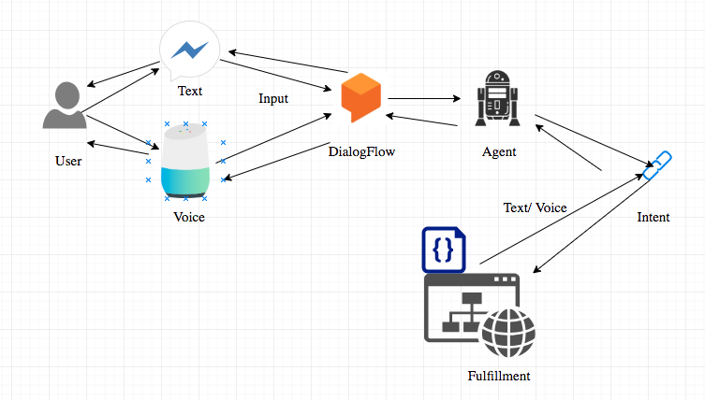

Figure 1- Conversation Flow within DialogFlow(image source: https://cdn-images-1.medium.com/max/1200/1*tZKE2D6wLbgOdWMuNQ4CiQ.png)

While DialogFlow allow information flow through textual input or voice, the designed HEX-Chatbot is purely based on text input. The software agent architecture within DialogFlow is shown below in Fig 2.

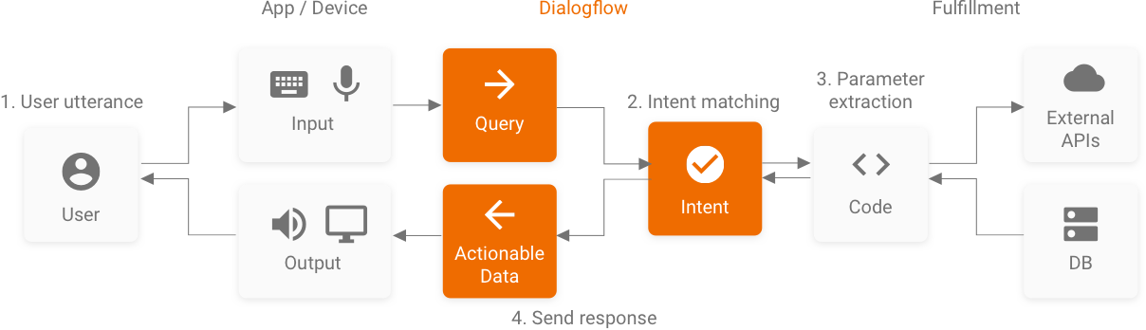

Figure 2: Software Agent Architecture for DialogFlow  
(image source: <https://dialogflow.com/docs/images/intro/fulfillment-diagram.png>)

### SYSTEM ARCHITECTURE

The system architecture of the ISS-Hex Chatbot is as illustrated below in Fig.3. The system architecture is similar to that of the DialogFlow software agent architecture in Fig. 2

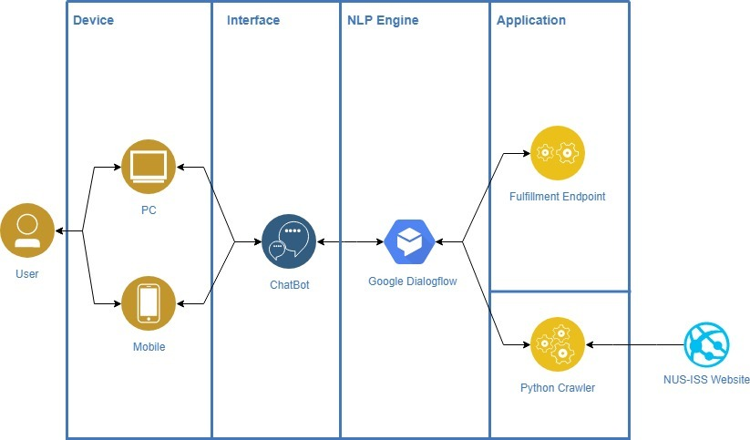

Figure 3: System Architecture of Hex Chatbot

The core modules of the ISS-HEX chatbot system are made out of the parts and corresponding functions in Table 1 below.

|  |  |  |
| --- | --- | --- |
| **No** | **Module** | **Function** |
| 1 | User input interface | To serve as a platform for users to input their queries |
| 2 | Natural language processing | To transform unstructured text input into structured and logic form so that the information can be processed and make-sense of by the DialogFlow agent (intent and slot/entity detection) |
| 3 | Fulfillment | Intent and entity detected will be matched to the business logic configured and once the matching is successful, a dynamic response can be constructed based on the matched intent and its corresponding information. |
| 4 | Python Crawler | To retrieve information from the NUS-ISS Website |

### 3. METHODOLOGY

The ISS-HEX chatbot is designed sequentially by considering the following aspects.

**3.1. Intent and entity designs**

A list of 100 possible user questions (FAQs) is defined and compiled into the DialogFlow (see Appendix A). From this list of FAQs, a total of 50 different intents and 10 entities are identified and an example is shown in Table 2. This set of FAQs will then serve as natural language utterances or training phrases to train the machine learning (ML) models in DialogFlow. Concurrently, during the compilation of utterances, the customized entities are also annotated. Based on this set of defined data, DialogFlow will expand upon them to create the intent model and the ML model will later be able to make decisions about which intent to be matched to a user query to generate an appropriate response. This flow is illustrated in Fig.4

*Table 2: Example of utterance with matching entity and corresponding intent*

|  |  |  |
| --- | --- | --- |
| Utterance | Entity | Intent |
| What are the application requirements for Post Graduate Diploma? | $GraduateProgramType | GetApplicationRequirement |
| What kind of programme does Graduate Programmes provide? | $EducationType | GetProgrammeType |
| what are the modules in Mtech IS? | $Qualification | GetModuleDetails |

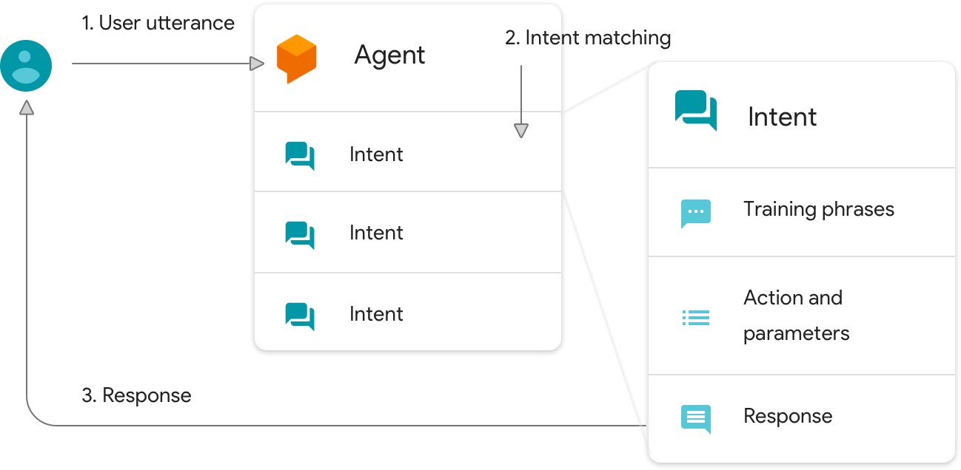

Figure 4: Intent matching to Utterance

(Imagsource:<https://cloud.google.com/dialogflow-enterprise/docs/images/intent-matching-overview.png>)

**3.2. Knowledge base design**

The web crawling is performed to retrieve the required information from <https://www.iss.nus.edu.sg/> via the Python library ‘beautifulsoup’.

**3.3. Natural language processing**

When a user first input a question in the form of unstructured text, this request needs to be understood by the chatbot system. This can be done by first splitting the text input into separate words for tagging. The tagged words will then be classified to the defined intents and entities by the ML algorithms in DialogFlow. This process transforms the unstructured text input into logical form to be processed by the DialogFlow agent. The ML algorithm used is the hybrid whereby the agent will first attempt to match based on rule-based grammer and if the match fails, the agent will employ the ML matching. The accuracy of the outcome from the ML matching can be tuned via the ML classification threshold. A threshold value of 0.3 is selected, and thus if the confidence value is less than this threshold value, then the fallback intent is matched. Subsequently, the matched intent and entity will be passed into the fulfillment to generate the response.

**3.4. Fulfillment**

The intent that is passed from the intent classification is matched to the business logic defined in the python script via the webhook. Once the intent matching is successful, then its corresponding information will be retrieved from the ISS website via the Python crawler and an appropriate response is constructed. This response will be returned back to DialogFlow via the webhook which will then be consumed by the user.

**3.5. Deployment**

The user will consume the response via the DialogFlow dialogue interface hosted by Google. The python script to perform the fulfillment is hosted in Heroku via Gunicorn which is a Python WSGI HTTP Server.

4) EVALUATIONo evaluate our chatbot, there are two aspects with categories we assess, namely

1. Efficiency based on performance
2. Effectiveness based on functionality and humanity

The prototype of the HEX-Chatbot is Deploy out online to [here(CLICK LINK)](https://bot.dialogflow.com/075d5e8e-98c8-467e89-58-c0ab300ff2a8)

The following outputs are noted

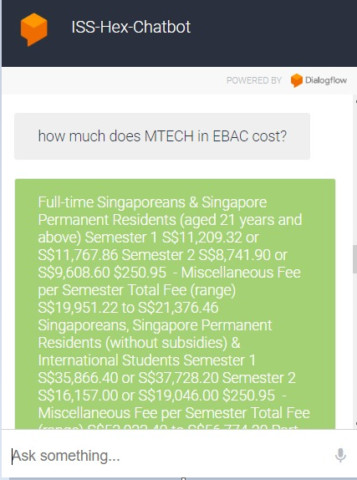 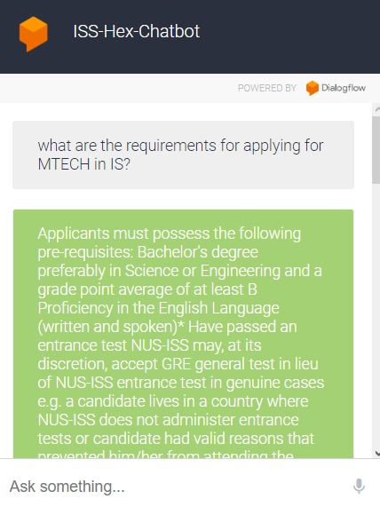

### 4.1) PROPOSED IMPROVEMENTS

Based on the observed responses of the HEX Chatbot to user input, we suggest the following improvements.

**More robust syntax recognition**

Currently the HEX Chatbot is rigid in the information extraction to make meaning of the intent of the user’s queries which results it in not understanding the syntax of the query which does not follow proper grammar. Refer to screenshot below

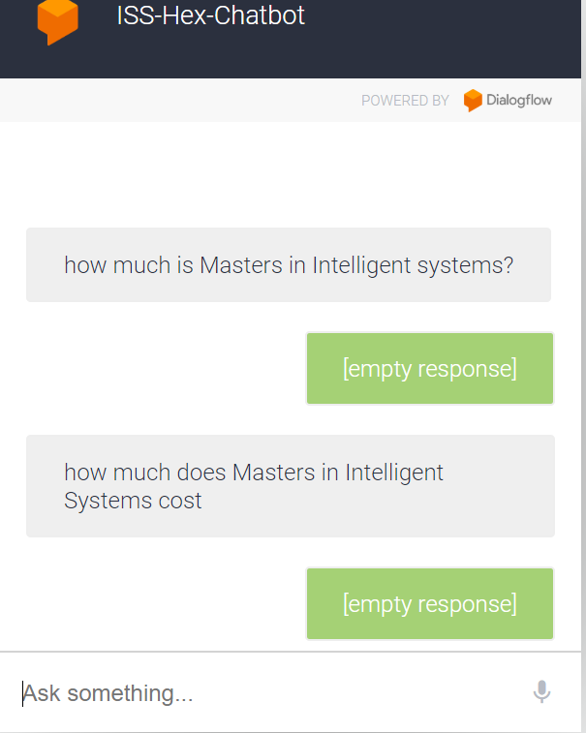

To address this limitation, a grammar engine syntax such as Grammarly could be integrated into the chatbot system to correct the syntax of the user’s query and return some responses to clarify with the user what their actual intent was with suggestions of rephrased corrected intents and allow the user to select the closest match that can lead to the A.I to match with a corresponding response.

**Recognition of Micro-intents**

The HEX Chatbot currently can only take primary queries, meaning it can respond to a simple query but not remember it if a user requires further detail based based on the response from the primary query. Integrating micro-intents into the system will create a more seamless experience for the user that patterns after the actual human experience of search based query where a user usually requires more related detail after finding some intial information.